Model A
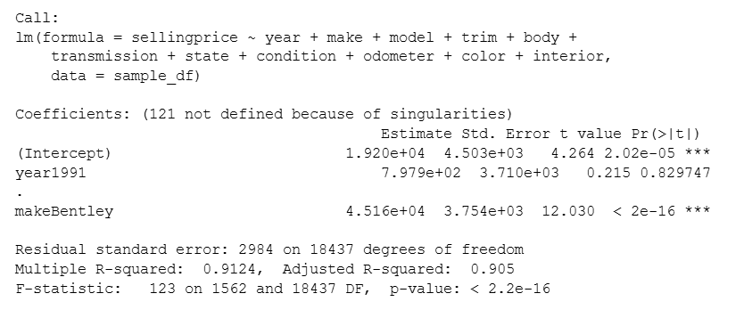
The summary of Model A indicates that the overall regression is statistically significant, with a model p-value < 0.01. This suggests that the predictor variables collectively contribute to explaining variation in selling price. The model also reports a very high Multiple R-squared value of 0.9124, meaning it explains roughly 91% of the variation in selling price. The Adjusted R-squared of 0.905 confirms that the model remains strong even after accounting for the large number of predictors. However, the output also reports “121 coefficients not defined because of singularities.” This occurs when certain dummy variables are perfectly collinear with others, meaning the model matrix does not have full rank.

The ANOVA output shows that most categorical variables are statistically significant predictors of selling price; however, color is one of the least significant variables, and interior also has marginal significance. In contrast, variables like year, make, model, trim, and condition contribute strongly but also introduce multicollinearity due to their high cardinality.

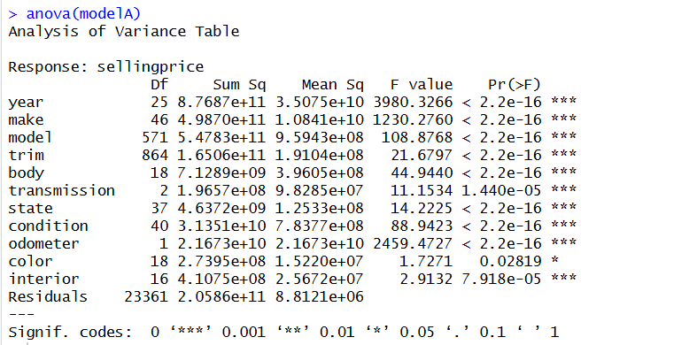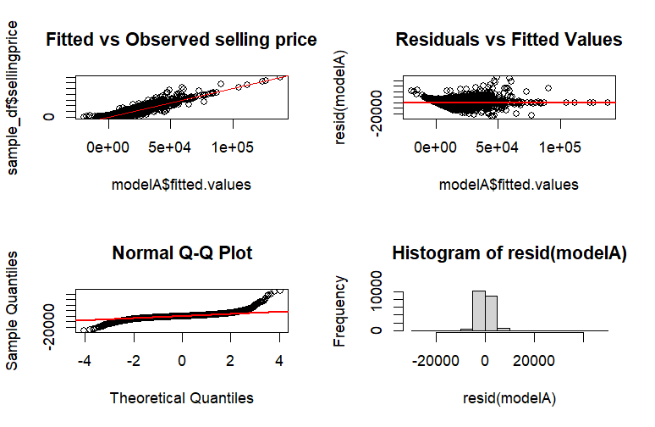

Diagnostic plots further highlight these issues. The fitted vs. observed plot shows that the model captures the overall upward price trend well, but the residuals vs fitted plot reveals a clear pattern rather than random scatter, indicating model misspecification. The Q–Q plot shows approximate normality, but the residual histogram is heavily tailed, suggesting the presence of outliers and skewed error distribution.

Taken together, the evidence indicates that although Model A achieves a high R-squared, the model suffers from multicollinearity, overfitting due to many categorical levels, and the influence of outliers, all of which reduce reliability and interpretability. These limitations highlight the need for data cleaning and model refinement in future models.

Model B

To improve data quality, Model B was built on a dataset cleaned using a two-step outlier removal method:
- IQR filtering removes extreme values of salesDifference, reducing noise and eliminating unrealistic observations.
- Winsorization (1st–99th percentile capping) controlled the influence of remaining high but valid values. This stabilized the distribution while preserving real market variation.

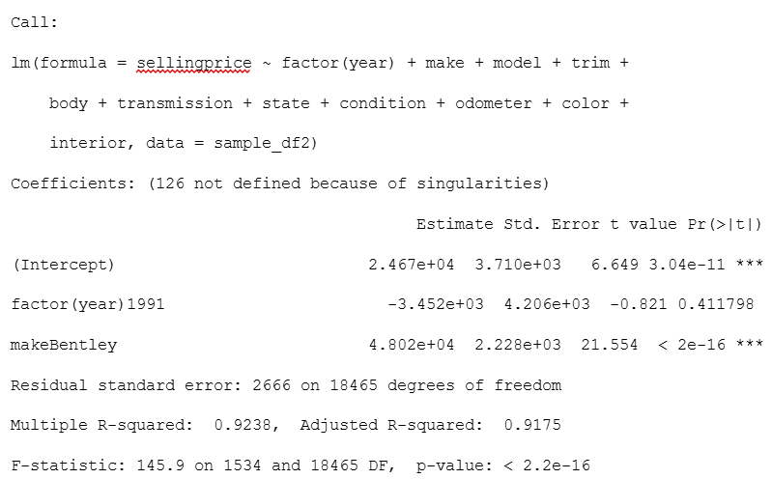
Model B shows strong statistical performance. The regression is highly significant (p < 0.01), and the Multiple R² = 0.9238 with Adjusted R² = 0.9175 indicates that the model explains roughly 92% of the variation in selling price—slightly higher than Model A. This suggests that removing extreme outliers improved model stability. However, R reports 126 coefficients “not defined due to singularities,” meaning that even after cleaning, many dummy variables—especially for model and trim—remain perfectly collinear and are automatically dropped.

The ANOVA results confirm that while most predictors (year, make, body, condition, odometer) are highly significant, model and trim still have far too many categories, creating redundancy and multicollinearity issues. Color continues to be one of the least significant predictors.
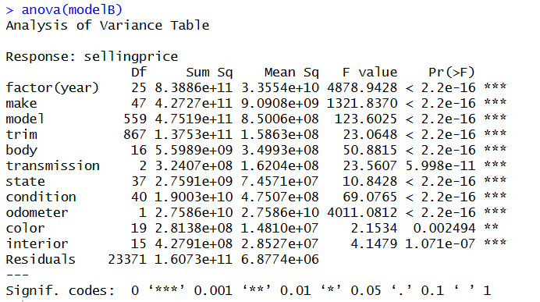
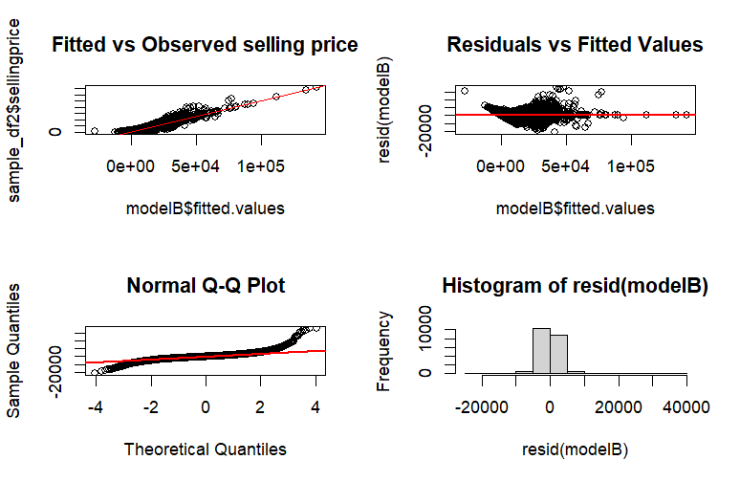

Using the model, we found that fitted vs. observed values follow the expected trend, but the Residuals vs Fitted plot displays a pattern rather than random scatter, indicating model misspecification. The Q–Q plot shows approximate normality, yet the residual histogram remains heavily tailed, confirming that even after cleaning, the error distribution is still imperfect.

Overall, Model B performs better than Model A due to reduced noise, but it continues to have from multicollinearity and high-cardinality categorical variables, limiting its interpretability and reliability.

Model C

Model C was developed to address the multicollinearity and high-cardinality issues observed in Models A and B. To reduce redundancy, we combined make, model, and trim into a single categorical variable (make_model_trim), significantly lowering the number of dummy variables and preventing singularity errors. Additionally, applying a log transformation to both selling price and odometer helped stabilize variance and correct the heteroscedastic patterns seen earlier. We removed color as it was not as statistically significant compared to other variables.
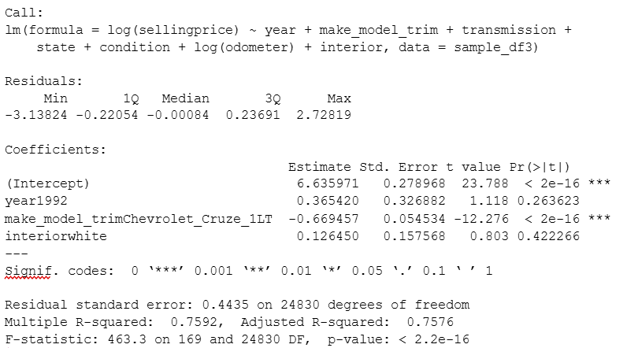
The performance of Model C is strong and statistically significant, with a Multiple R² of 0.759 and Adjusted R² of 0.758, indicating that the model explains about 76% of the variation in log-selling price. Although this R² is lower than in Models A and B, it is more realistic and avoids the inflation caused by thousands of dummy variables and multicollinearity in earlier models. The residual standard error of 0.4435 shows that log-transformation successfully reduced spread and improved model stability.
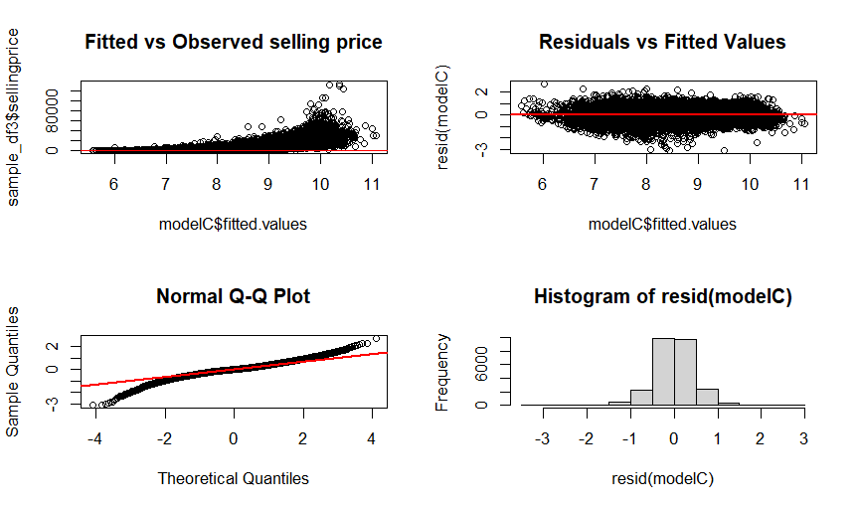
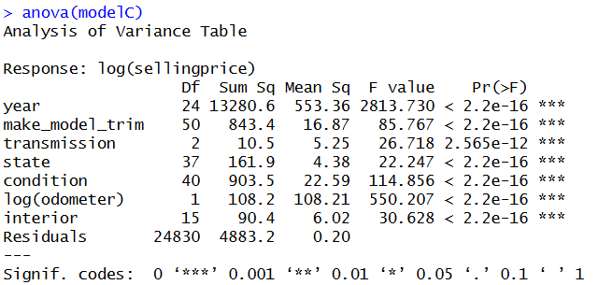

The ANOVA confirms that make_model_trim categories remain significant, indicating that combining them still captures important market differences across vehicle variants. Transmission type, interior color, and state effects also remain statistically relevant.

The plots confirm improvement: residuals are more evenly distributed, heteroscedasticity is reduced, and the Q–Q plot better aligns with normality. The overall structure suggests a much healthier model with fewer violations of linear regression assumptions.

In summary, Model C is the most interpretable and statistically reliable model among the three. While Models A and B overfit due to excessive dummy variables and multicollinearity, Model C provides a cleaner representation of real pricing behavior and is suitable for prediction and inference which was confirmed by the VIF score.

Business Question

We explored and analyzed a large dataset of used vehicle sales to determine how different car features can affect the selling price based on various car characteristics such as year, make, model, trim, condition, odometer reading, body type, transmission, and state of sale. An important aspect of this study is to understand how the MMR (Manheim Market Report) value, a widely used industry benchmark for pricing vehicles, differs from the actual selling price. We aim to uncover whether vehicles are sold above or below their estimated market value, and identify which factors contribute to this variation by comparing the difference between the MMR and the actual selling price. Understanding the pricing deviations can provide valuable insights for dealerships, buyers, and pricing analysts to help identify patterns, estimate fair market value, and make more data-driven decisions in vehicle pricing and negotiation.

To begin the analysis, we created another column called sales difference and performed summary statistics on the dataset using describe(). This helped us understand the distribution of numerical variables such as sellingprice, mmr, odometer and sales difference. This provided key insights such as:

The selling price is $158 less than the MMR. 25% of the cars either sell 800$ below the mmr or 650$ above the mmr. A car was sold for 87,750$ less than the MMR which suggests its an outlier.A car was sold for $207,200 more than the MMR which also suggests its an outlier. The standard deviation is 1741.0671 which is relatively large compared to the mean. This shows us there are many outliers.

The salesDifference values after cleaning show a much more realistic and stable distribution compared to the raw data. The mean of “- 49.9” indicates that, on average, vehicles sold for prices very close to their MMR value, with only a slight negative deviation. The standard deviation has been reduced to about 1,068, reflecting far less variability than before and confirming that extreme outliers were successfully removed. The interquartile range (- 700 to +600) represents typical market fluctuations, while the new minimum (- 2,700) and maximum (+2,500) values indicate that Winsorization preserved valid but extreme observations without allowing unrealistic values to distort the distribution. Overall, the cleaned salesDifference now accurately captures genuine price deviations and is well-suited for regression modeling.

Lastly, we created a box and whisker plot that shows us the comparison between the data before and after cleaning the data.
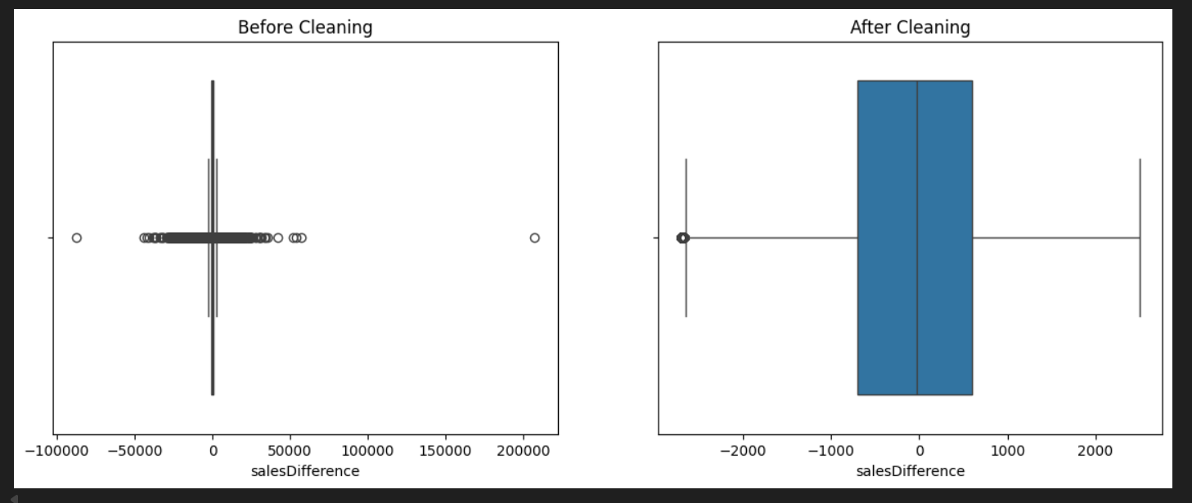

.Most vehicles sell close to their MMR value after data cleaning
.The distribution shifted closer to zero, indicating better alignment with market estimates
.Removing outliers reduced variability by ~39%, revealing the true underlying pattern
.The slight negative mean suggests vehicles typically sell marginally below MMR on average

Business context:

The sales difference of 49.9 when comparing the selling price to the MMR value enables accurate pricing strategies and can also help in generating margins for profit.

The lower standard deviation means more consistent revenue prediction and can also mitigate losses.

Understanding the relationship between selling price and MMR prevents buyers/sellers overpaying for a vehicle.

